**Week 4 Homework Submission File: Linux Systems Administration**

**Step 1: Ensure/Double Check Permissions on Sensitive Files**

1. Permissions on /etc/shadow should allow only root read and write access.
   * Command to inspect permissions: **ls -l /etc/shadow**
   * Command to set permissions (if needed): **sudo chmod 600 /etc/shadow**
2. Permissions on /etc/gshadow should allow only root read and write access.
   * Command to inspect permissions: **ls-l /etc/gshadow**
   * Command to set permissions (if needed): **sudo chmod 600 /etc/gshadow**
3. Permissions on /etc/group should allow root read and write access, and allow everyone else read access only.
   * Command to inspect permissions: **ls -l /etc/group**
   * Command to set permissions (if needed): **sudo chmod 644 /etc/group**
4. Permissions on /etc/passwd should allow root read and write access, and allow everyone else read access only.
   * Command to inspect permissions: **ls -l /etc/passwd**
   * Command to set permissions (if needed): **sudo chmod 644 /etc/passwd**

**Step 2: Create User Accounts**

1. Add user accounts for sam, joe, amy, sara, and admin.
   * Command to add each user account (include all five users): **sudo adduser sam**
   * **Sudo adduser joe**
   * **Sudo adduser amy**
   * **Sudo adduser sara**
   * **Sudo adduser admin**
   * **(bash only lets me add two users at a time or it displays an error stating this)**
2. Ensure that only the admin has general sudo access.
   * Command to add admin to the sudo group: **sudo usermod -G sudo admin**

**Step 3: Create User Group and Collaborative Folder**

1. Add an engineers group to the system.
   * Command to add group: **sudo groupadd –system engineers**
2. Add users sam, joe, amy, and sara to the managed group.
   * Command to add users to engineers group (include all four users): **sudo adduser sam engineers**
   * **sudo adduser joe engineers**
   * **sudo adduser amy engineers**
   * **sudo adduser sam engineers**
3. Create a shared folder for this group at /home/engineers.
   * Command to create the shared folder: **sudo mkdir /home/engineers**
4. Change ownership on the new engineers' shared folder to the engineers group.
   * Command to change ownership of engineer's shared folder to engineer group: **sudo chown :engineers /home/engineers/**

**Step 4: Lynis Auditing**

1. Command to install Lynis: **sudo wget https://downloads.cisofy.com/lynis/lynis-2.7.3.tar.gz**
2. Command to see documentation and instructions:

**man lynis**

**sudo lynis--help**

1. Command to run an audit: **sudo lynis audit system**
2. Provide a report from the Lynis output on what can be done to harden the system.
   * Screenshot of report output: All snapshots included with file uploaded just posting Lynis security scan details in here (31 screenshots total, too many to fit in this page)

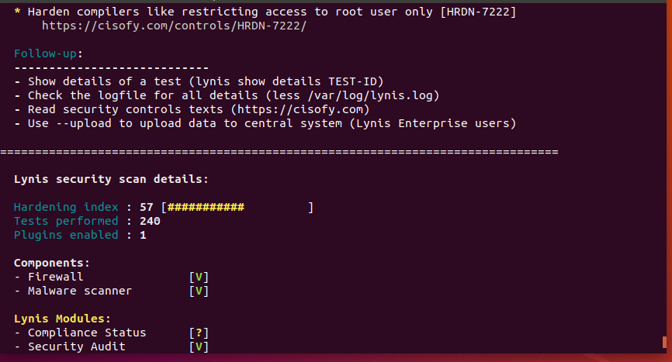

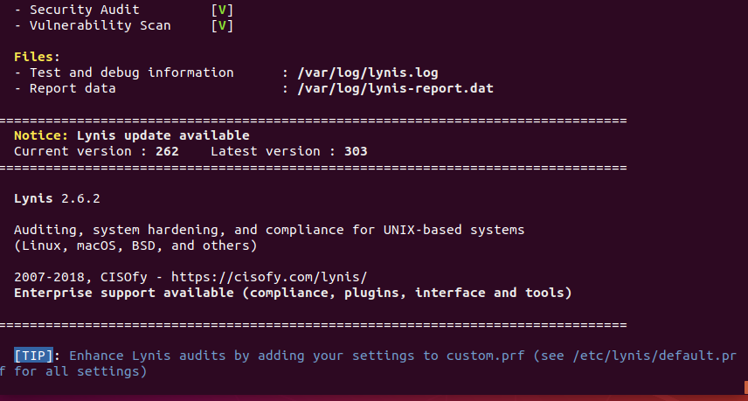

**Bonus**

1. Command to install chkrootkit**: sudo apt install chkrootkit -y**
2. Command to see documentation and instructions: **sudo --help chkrootkit**
3. Command to run expert mode: **sudo chkrootkit -x**
4. Provide a report from the chrootkit output on what can be done to harden the system.
   * Screenshot of end of sample output:

